Question 1
Recreate the following website using HTML and CSS selectors:
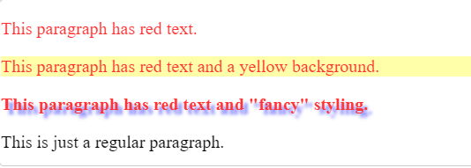

Memo
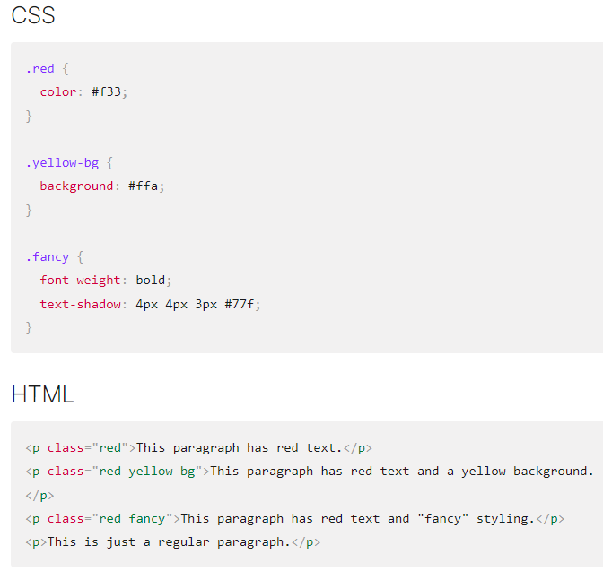

Question 2
Recreate the following website using HTML and CSS selectors:
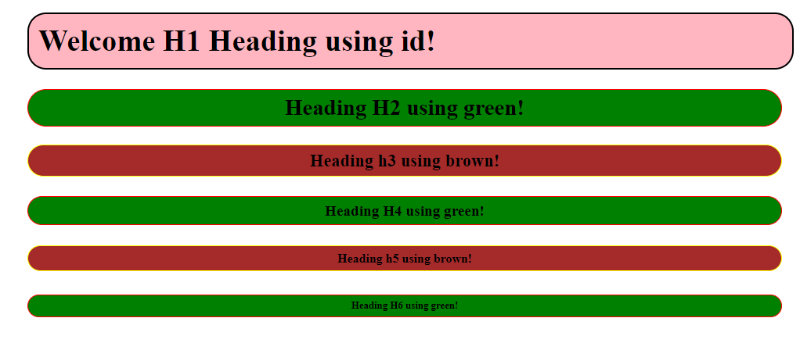
MEMO
<style>
#welcome {
background-color: lightpink;
border: solid 2px;
border-radius: 20px;
padding: 10px;
margin-left: 400px;
width: 50%;
}
.green {
background-color: green;
border: solid 1px red;
padding: 5px;
border-radius: 20px;
width: 50%;
text-align: center;
margin-left: 400px;
}
.brown{
background-color: brown;
border: solid 1px yellow;
padding: 5px;
border-radius: 20px;
width: 50%;
text-align: center;
margin-left: 400px;
}
</style>

<body>

<h1 id="welcome">Welcome H1 Heading using id!</h1>
<h2 class="green">Heading H2 using green!</h2>
<h3 class="brown">Heading h3 using brown!</h3>
<h4 class="green">Heading H4 using green!</h4>
<h5 class="brown">Heading h5 using brown!</h5>
<h6 class="green">Heading H6 using green!</h6>

</body>

Question 3
Recreate the following website using HTML and CSS selectors:
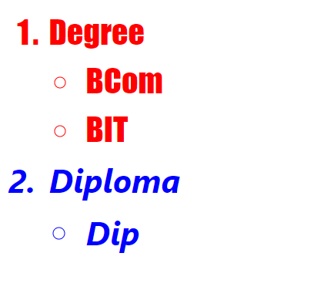
<style>
.diploma {
padding: 5px;
color: blue;
font-size: 35px;
font-family: 'Segoe UI', Tahoma, Geneva, Verdana, sans-serif;
font-weight: bold;
font-style: italic;
}
.degree{
padding: 5px;
color: red;
font-size: 35px;
font-family:fantasy;
font-weight:lighter;
}
</style>

<body>

<ol>
<li class="degree">Degree</li>
<ul>
<li class="degree">BCom</li>
<li class="degree">BIT</li>
</ul>
<li class="diploma">Diploma</li>
<ul>
<li class="diploma">Dip</li>
</ul>
</ol>

</body>

